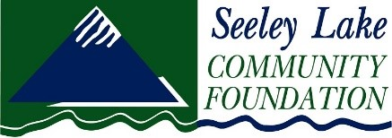

2023 SLCF Community Grant Report Form

We hope your project was a success! Please submit to info@slcfmt.org by January 31, 2024:
- This completed and signed (typed signature ok) Grant Report form
- 1-2 photographs of your 2023 grant project

These grant reporting materials must be returned prior to submitting any subsequent grants from the Seeley Lake Community Foundation. Any funds that were not used for the purpose designated must be returned with this report.

Organization___________________________________________________________________
Project________________________________________________________________________
Amount of SLCF grant funding awarded ______________
- Have all the grant monies been spent?
Select: Yes_____ No_____ If no, please explain.

- Were the objectives as stated on the original grant application achieved?
Select: Yes_____ No_____
If no, please explain:

- Do you assure that the activities under the grant were conducted in conformity with the terms of your 2021 SLCF Grant Agreement?
Select: Yes _____ No_____ If no, please explain:

- Please give a brief narrative (no more than 350 words) describing the outcomes of the project:

- Please submit 1-2 photos of your project.

Submitted by:
Name (print)______________________________________ Title______________________
Signature (type for e-signature) _________________________________________Date______________________
Email____________________________________________Phone_____________________

Please return to: info@slcfmt.org by January 31, 2024.
Or mail to:
SLCF
PO Box 25
Seeley Lake, MT 59868

Questions: 406-677-3506

