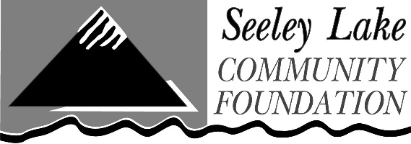
SLCF Community Grants Program
2024 Grant Application

Submit to info@slcfmt.org by January 31, 2024

Questions: (406) 677-3506 or info@slcfmt.org http://www.seeleylakecommunityfoundation.org/community-grants-program

*New for 2024 grant cycle: A maximum of 35% of request can be used for administrative costs (staffing)*

Grant Request Information
- Project Name:
- Amount Requested (up to $3,000):
- Total Cost of Project:
- Please select which of our five areas of interest this project addresses (feel free to select more than one option):
Education __
Arts & Culture ___
Community & Economic Development ___
Natural Resources & Conservation ___
Basic Human Needs___

Organization Information
- Name of Organization:
- Are you a 501c3 nonprofit?
- Tax Identification Number:
- Mission Statement:
- Mailing Address:
- Primary Contact Person:
- Phone Number:
- Email Address:
- Secondary Contact Person:
- Phone number:
- Email Address:
Narratives
- Describe your proposed project.
- How will this project serve the community of Seeley Lake, Montana?
- What does success look like for this project?
- What other funding sources and/or partnerships do you have for this project?
- What is your long-term management/ maintenance plan?
Required Attachments
- Project budget Email budget, along with this application - to: info@slcfmt.org
- Names of current board members
Required signature
- Signature This application may be digitally signed by typing your name:
- Title:
- Date:

